**Internship Report**

Student Name: Kruthi B K

College/University: SMVITM

Internship Duration: 1 Month

# **Introduction**

This internship at NullClass focused on Automation Testing using Selenium WebDriver. The primary objective was to gain practical exposure to automation frameworks, test execution, and validation of real-time e-commerce functionalities on Amazon. Selenium was used along with Java, TestNG, and Maven to build structured and reusable test cases.

# **Tools & Setup**

The following tools and technologies were used for the project:

*Java (programming language for writing scripts)  
 *Selenium WebDriver (automation tool)  
 *TestNG (testing framework for managing test execution)  
 *Maven (build automation and dependency management)  
 *ChromeDriver (browser driver for executing tests on Chrome)  
 *Visual Studio Code / IntelliJ IDEA (IDE for development)

**Task 1: Amazon Login Page Validation**

This task automated the login functionality of Amazon.  
It entered valid and invalid credentials to check responses.  
Assertions were added to verify login success or failure messages.  
The script ensured reliability of the login process.

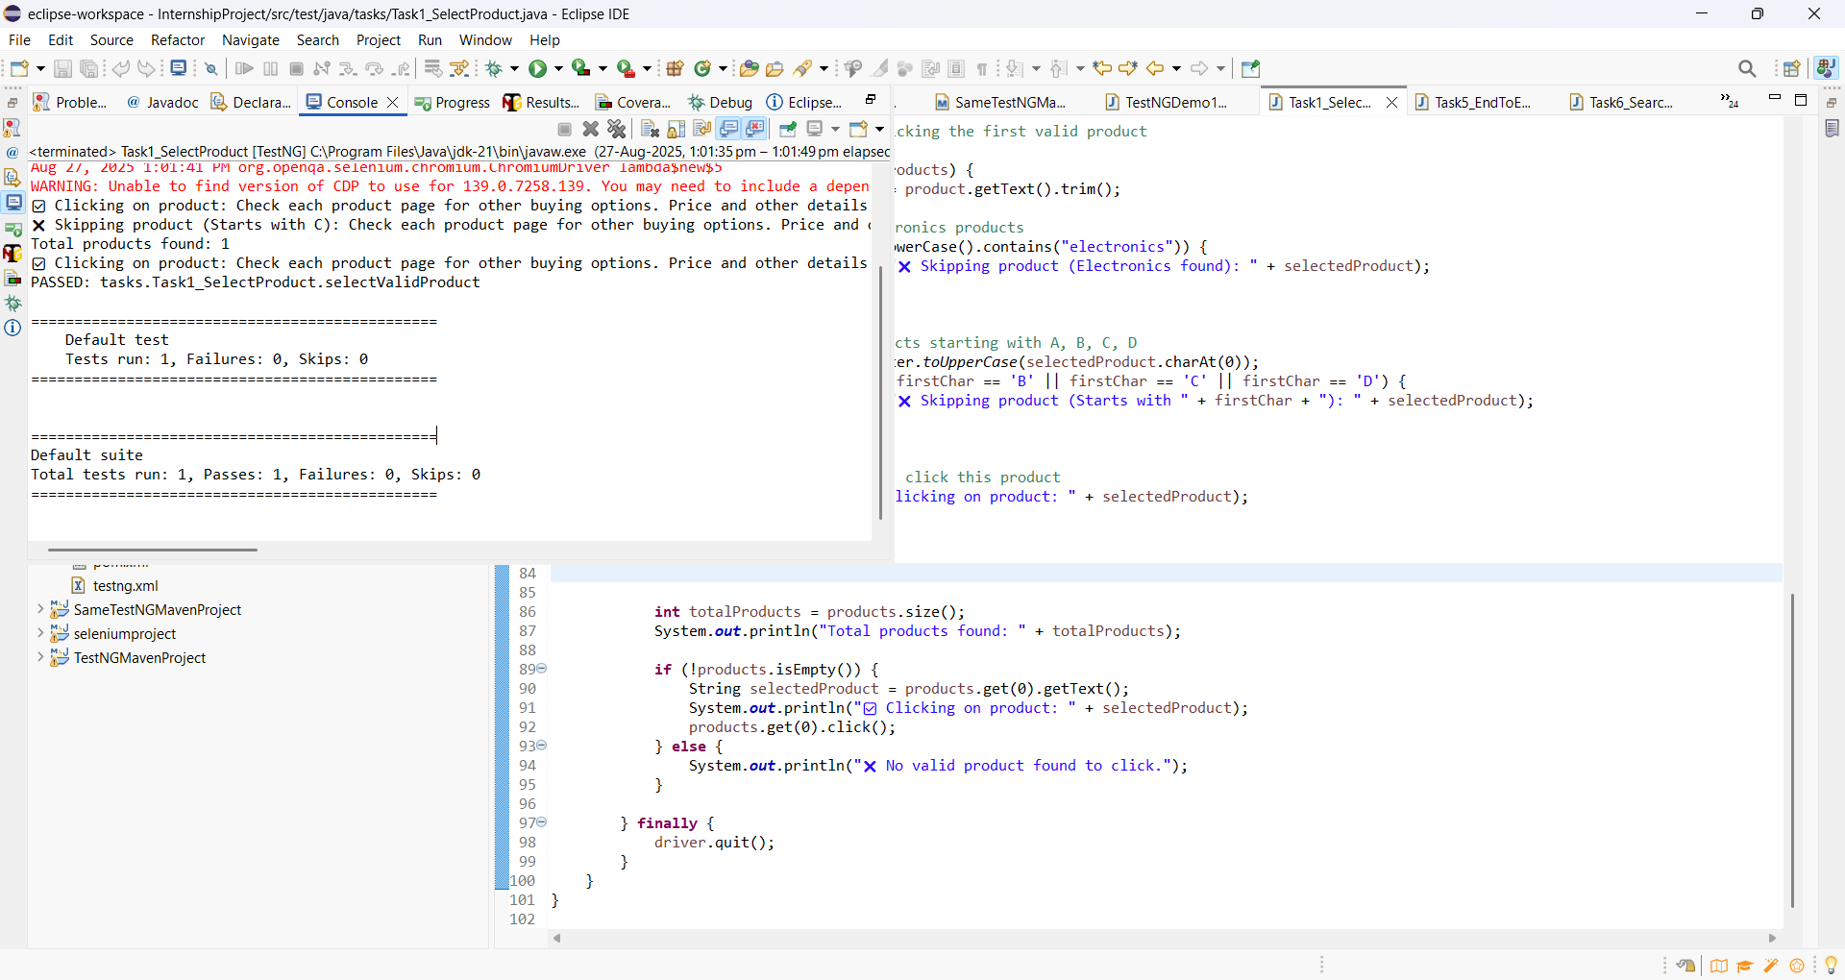

**Task 2: Add to Cart with Time Restriction**

This task automated adding products to the shopping cart.  
It only executed within a given time window (e.g., 12 PM–3 PM).  
The script searched, selected products, and added them to the cart.  
It validated cart updates and handled time-based restrictions.

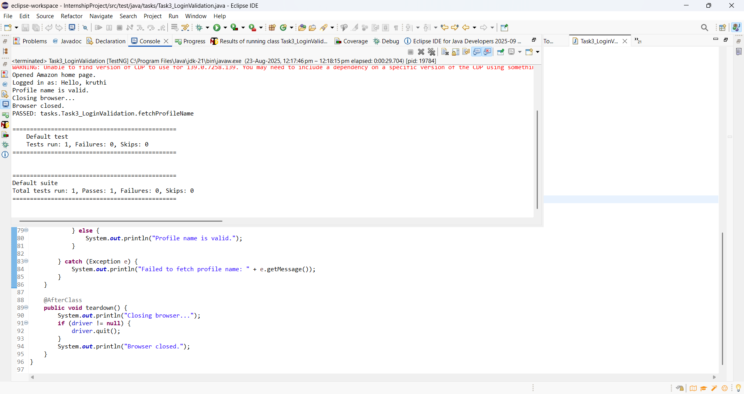

**Task 3: Profile Name Validation**

This task tested login and validated the user profile name.  
The script ensured the profile name did not contain disallowed letters (A, C, G, I, L, K).  
Execution was restricted between 12 PM and 3 PM.  
It helped enforce specific business rules on profile names.

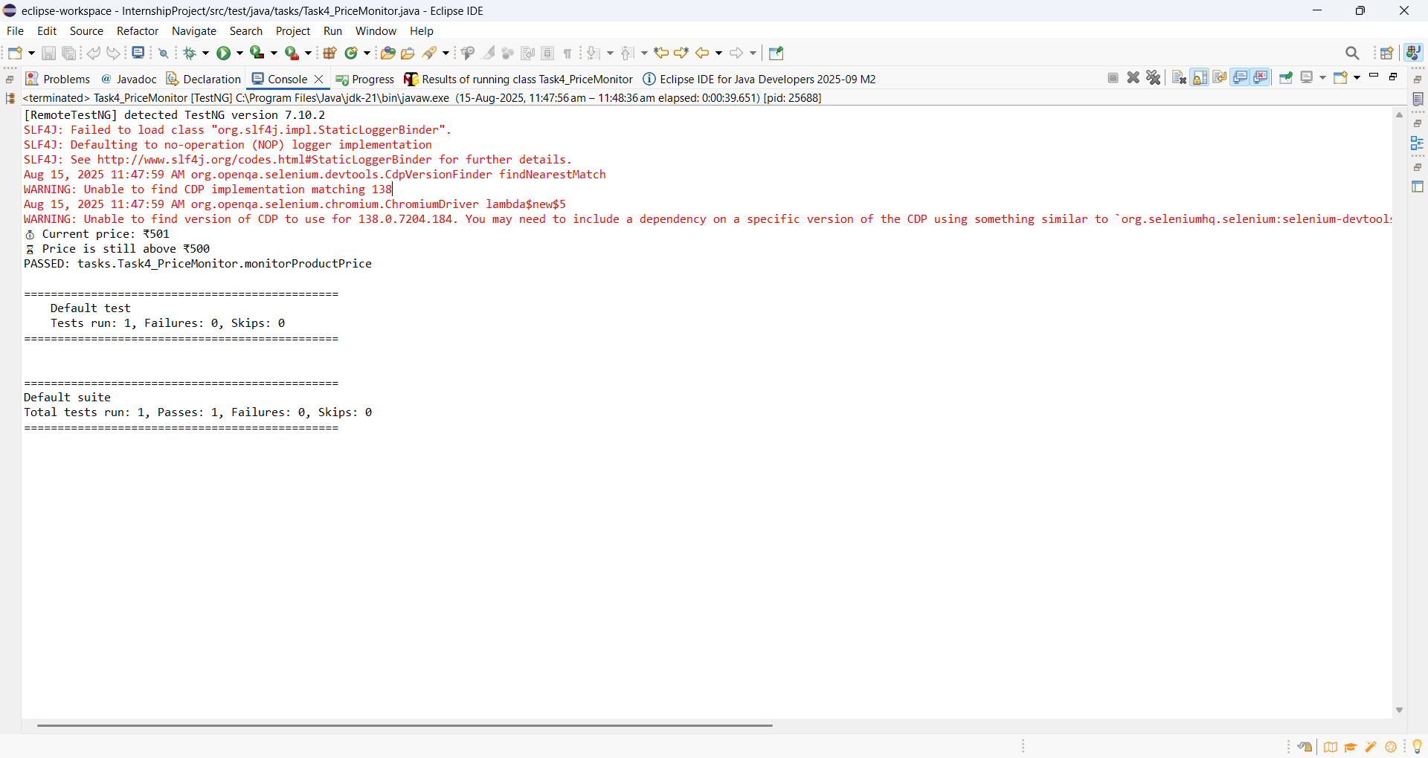

**Task 4: Product Search Filtering**

This task automated product search on Amazon.  
It skipped products in the Electronics category and names starting with A–D.  
The script selected a valid product and opened its details page.  
Execution was restricted to run only between 3 PM and 6 PM.

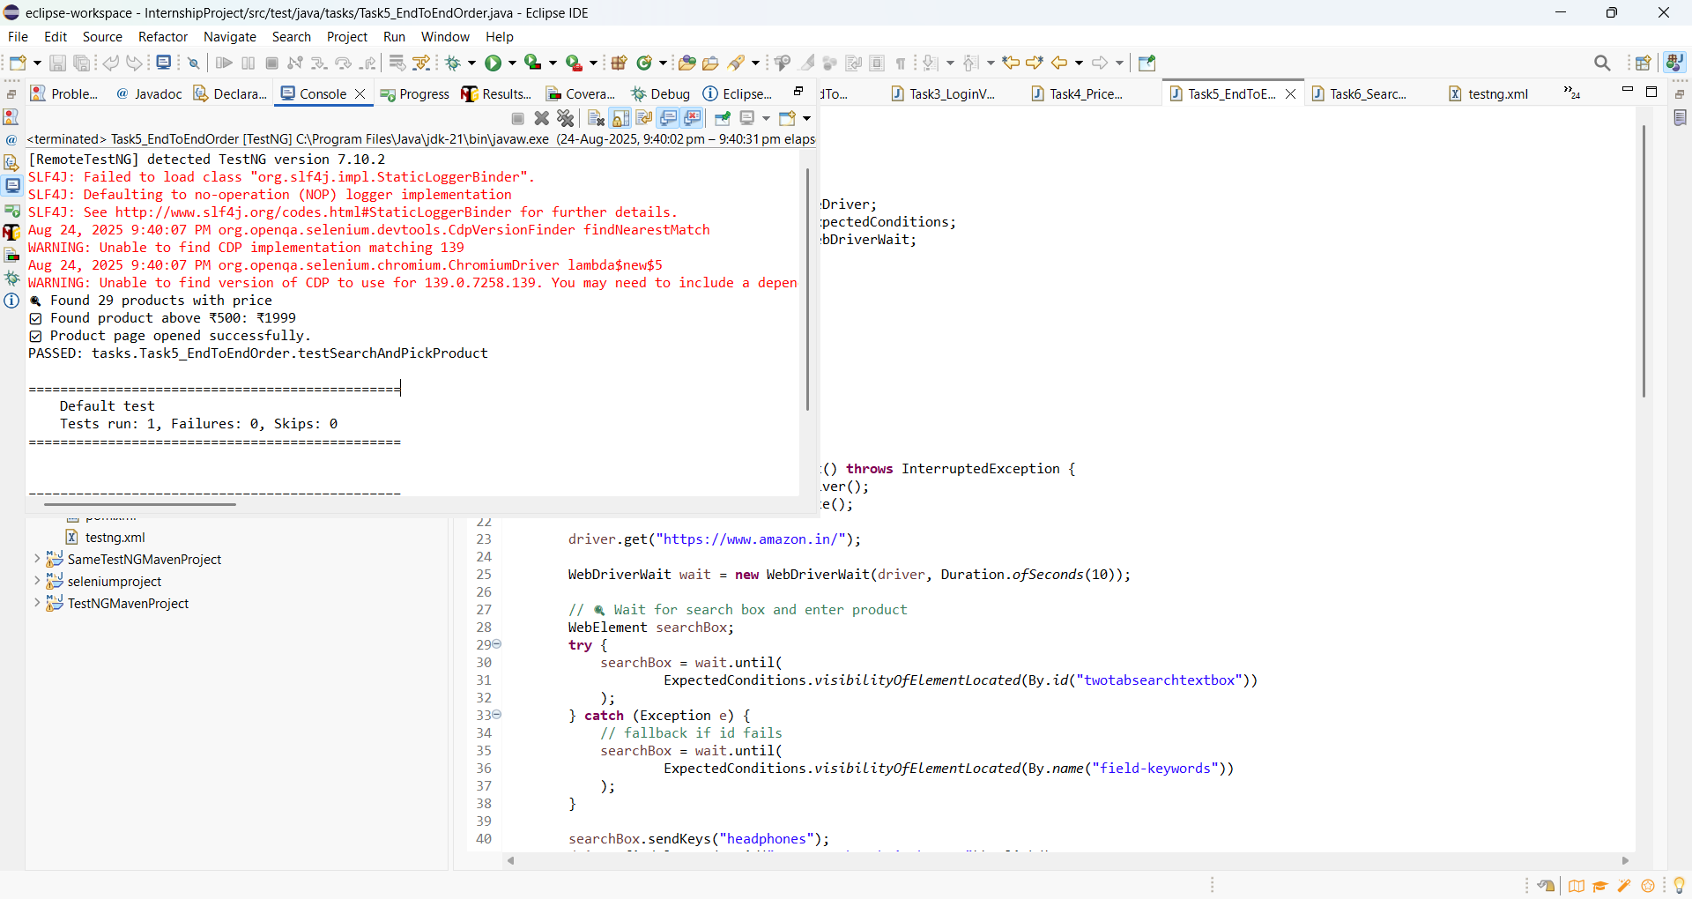

**Task 5: End-to-End Order Flow**

This task simulated a complete purchase process.  
It searched for products and skipped items below a price threshold.  
The script added a product to the cart and proceeded to checkout.  
If no valid product was found, the test was skipped

# 

# **Task 6: Search with Filters**

# **This task automated applying filters on Amazon search results. It validated search with brand, price range, and category filters. The script ensured only filtered products were displayed. It confirmed that the filtering functionality worked correctly.**

# 

# **Challenges & Solutions**

*Handling dynamic elements on Amazon required using explicit waits and flexible locators.  
*Implementing time-based restrictions ensured the scripts only executed during specific hours.  
*Managing filters like brand and price required conditional handling elements were not found.  
*Synchronization issues were solved using Thread.sleep() and WebDriver waits.

# **Conclusion**

The internship at NullClass provided hands-on experience with automation testing. Through these tasks, I gained practical exposure in writing robust Selenium test scripts, managing test execution with TestNG, handling real-world dynamic web elements, and working with Maven. This project enhanced my problem-solving skills and prepared me for real-time automation challenges.